LCG NAIL SUPPLIES
SAFETY DATA SHEET

STAIN RESISTANT TOPCOAT

Section 1: Identification of the substance/mixture and of the company/undertaking

  - Product identifier

Product name: Stain Resistant Topcoat

  - Relevant identified uses of the substance or mixture and uses advised against

Use of substance / mixture: (PC39: Cosmetics, personal care products)

1.3. Details of the supplier of the safety data sheet

Company name:

LCG NAIL SUPPLIES
5 Moxham Street Cranebrook NSW 2749

Tel: 0481451050

Email: sales@lcgnailsupplies.com.au

Emergency telephone number: 0481451050
(office hours only)

Section 2: Hazards identification

2.1. Classification of the substance or mixture

Classification under CLP: STOT SE 3: H336; Eye Irrit. 2: H319; Flam. Liq. 3: H225; Skin Sens. 1B: H317
Most important adverse effects: highly flammable liquid and vapour. May cause an allergic skin reaction. Causes serious eye irritation. May cause drowsiness or dizziness.

WARNING: MAY CAUSE AN ALLERGIC SKIN REACTION. AVOID SKIN CONTACT. CAUSES EYE IRRITATION.

2.2. Label elements

Label elements:
Hazard statements: H225: flammable liquid and vapour.
H317: May cause an allergic skin reaction.
H319: Causes serious eye irritation.
H336: May cause drowsiness or dizziness.

Signal words: Danger
Hazard pictograms: GHS02: Flame
GHS07: Exclamation mark

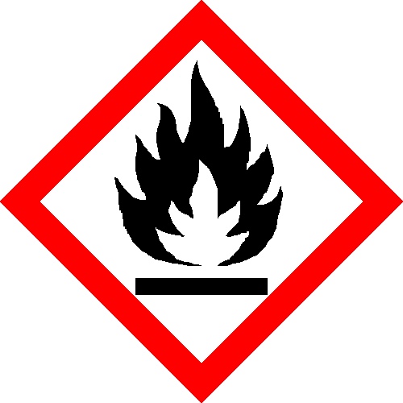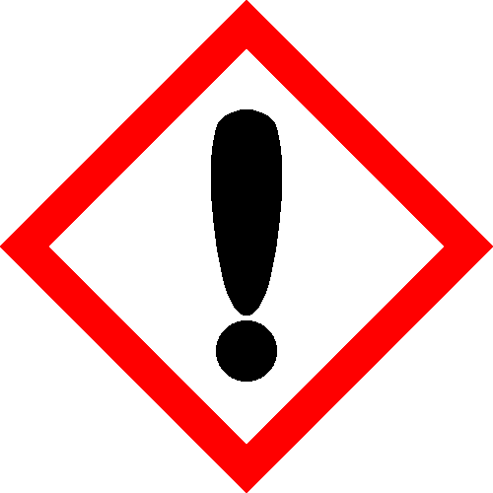

Precautionary statements: P210: Keep away from heat, hot surfaces, sparks, open flames and other ignition sources. No smoking.
P241: Use explosion-proof electrical/ventilating/lighting/.. equipment.
P280: Wear protective gloves/protective clothing/eye protection/face protection.
P302+352: IF ON SKIN: Wash with plenty of water/.
P303+361+353: IF ON SKIN (or hair): Take off immediately all contaminated clothing. Rinse skin with water/shower.
P304+340: IF INHALED: Remove person to fresh air and keep comfortable for breathing.

2.3. Effects of exposure:

INGESTION: if product is swallowed, may cause nausea, vomiting, diarrhea and central nervous system depression.

EYES & SKIN: the liquid may produce eye discomfort and is capable of cause impairment of vision, eye inflammation.

INHALATION: vapour can irritate nose, throat. Symptoms can be cough, sneeze, difficulty breathing.

Section 3: Composition/information on ingredients:

- Ingredients

Chemical Components | CAS NO | INCI NO | Concentration WT%
Acrylates Copolymer | 25035-69-2 | Acrylates Copolymer | 80
Isobornyl Acrylate | 5888-33-5 | Isobornyl Acrylate | 16
Trimethylbenzoyl Diphenylphosphine Oxide | 75980-60-8 | Trimethylbenzoyl Diphenylphosphine Oxide | 3
Dimethicone | 9006-65-9 | Dimethicone | 1

Section 4: First aid measures

4.1. Description of first aid measures:

Skin contact: Remove all contaminated clothes and footwear immediately unless stuck to skin. Wash
immediately with plenty of soap and water.
Eye contact: Bathe the eye with running water for 15 minutes. Consult a doctor.
Ingestion: Wash out mouth with water. Consult a doctor.
Inhalation: Remove casualty from exposure ensuring one's own safety whilst doing so. Consult a
doctor.

4.2. Most important symptoms and effects, both acute and delayed

Skin contact: There may be irritation and redness at the site of contact.
Eye contact: There may be irritation and redness. The eyes may water profusely.
Ingestion: There may be soreness and redness of the mouth and throat.
Inhalation: There may be irritation of the throat with a feeling of tightness in the chest. Exposure may cause coughing or wheezing.
Delayed / immediate effects: Immediate effects can be expected after short-term exposure.

4.3. Indication of any immediate medical attention and special treatment needed

Immediate / special treatment: Eye bathing equipment should be available on the premises.

Section 5: Fire-fighting measures

Flash Point: 105 degrees Celsius

5.1. Extinguishing media:

Extinguishing media: Alcohol resistant foam. Water spray. Carbon dioxide. Dry chemical powder. Use water spray to cool containers.

5.2. Special hazards arising from the substance or mixture:

Exposure hazards: Highly flammable. In combustion emits toxic fumes. Forms explosive air-vapour mixture. Vapour may travel considerable distance to source of ignition and flash back.

5.3. Advice for fire-fighters:

Advice for fire-fighters: Wear self-contained breathing apparatus. Wear protective clothing to prevent contact with skin and eyes.

Section 6: Accidental release measures

6.1. Personal precautions, protective equipment and emergency procedures:

Personal precautions:

6.2. Environmental precautions:

Environmental precautions: Do not discharge into drains or rivers. Contain the spillage using bunding.

6.3. Methods and material for containment and cleaning up:

Clean-up procedures: Absorb into dry earth or sand. Transfer to a closable, labelled salvage container for
disposal by an appropriate method. Do not use equipment in clean-up procedure which may produce sparks.

Section 7: Handling and storage:

7.1. Precautions for safe handling:

Handling requirements: Avoid direct contact with the substance. Ensure there is sufficient ventilation of the area. Do not handle in a confined space. Avoid the formation or spread of mists in the air. Smoking is forbidden. Use non-sparking tools.

7.2. Conditions for safe storage, including any incompatibilities:

Storage conditions: Store in a cool, well ventilated area. Keep container tightly closed. Keep away from
sources of ignition. Prevent the build up of electrostatic charge in the immediate area.
Ensure lighting and electrical equipment are not a source of ignition.
7.3. Specific end use(s):

Specific end use(s): No data available

Section 8: Exposure controls/personal protection:

8.1 Control Parameters

DNEL/PNEC Values:

DNEL / PNEC No data available.

8.2 Exposure Controls:

Engineering measures: Ensure there is sufficient ventilation of the area. Ensure lighting and electrical
equipment are not a source of ignition.

Respiratory protection: Self-contained breathing apparatus must be available in case of emergency.

Hand protection: Protective gloves.

Eye protection: Safety glasses. Ensure eye bath is to hand.

Skin protection: Protective clothing.

Section 9: Physical and chemical properties

9.1. Information on basic physical and chemical properties:

State: Liquid
Colour: Colourless
Odour: Characteristic odour
Evaporation rate: Fast
Viscosity: NA
Flash point°C: NA

9.2. Other information

No data available.

Section 10: Stability and reactivity:

10.1. Reactivity

Reactivity: Stable under recommended transport or storage conditions.

10.2. Chemical stability

Chemical stability: Stable under normal conditions. Stable at room temperature.

10.3. Possibility of hazardous reactions

Hazardous reactions: Hazardous reactions will not occur under normal transport or storage conditions.
Decomposition may occur on exposure to conditions or materials listed below.

10.4. Conditions to avoid

Conditions to avoid: Heat. Hot surfaces. Sources of ignition. Flames.

10.5. Incompatible materials

Materials to avoid: Strong oxidising agents. Strong acids.

10.6. Hazardous decomposition products

Haz. decomp. products: In combustion emits toxic fumes.

Section 11: Toxicological information

11.1. Information on toxicological effects

Hazardous Ingredients

Chemical Components | NTP CARCINOGEN | LARC CARCINOGEN | COSHA CARCINOGEN
Acrylates Copolymer | NO | NO | NO
Isobornyl Acrylate | NO | NO | NO
Trimethylbenzoyl Diphenylphosphine Oxide | NO | NO | NO
Dimethicone | NO | NO | NO

Symptoms / routes of exposure:

Skin contact: There may be irritation and redness at the site of contact.
Eye contact: There may be irritation and redness. The eyes may water profusely.
Ingestion: There may be soreness and redness of the mouth and throat.
Inhalation: There may be irritation of the throat with a feeling of tightness in the chest. Exposure may
cause coughing or wheezing.

Delayed / immediate effects: Immediate effects can be expected after short-term exposure

Section 12: Ecological information

12. this product is not classified as environmentally hazardous.

12.1 Effects on animals and plants

No data

12.2 Effect on aquatic life

No data

Section 13: Disposal considerations:

13.1. Waste treatment methods:

Disposal operations: Transfer to a suitable container and arrange for collection by specialised disposal
company. Dispose in accordance to local council law.

Section 14: Transport information

14.1. UN number: UN1263 UN number: UN1263
14.2. UN proper shipping name: Shipping name: UN1263 PAINT RELATED MATERIAL
14.3. Transport hazard class(es): Transport class: 3
14.4. Packing group: Packing group: II
14.5. Environmental hazards: Environmentally hazardous: No Marine pollutant: No
14.6. Special precautions for user: Special precautions: No special precautions.

Section 15: Regulatory information

15.1. Safety, health and environmental regulations/legislation specific for the substance or mixture:

No data

15.2. Chemical Safety Assessment:

Section 16: Other information

Other information:

Phrases used in s.2 and s.3: EUH066: Repeated exposure may cause skin dryness or cracking.
H225: Highly flammable liquid and vapour.
H317: May cause an allergic skin reaction.
H319: Causes serious eye irritation.
H336: May cause drowsiness or dizziness.
H412: Harmful to aquatic life with long lasting effects.

Legal disclaimer: The above information is believed to be correct but does not purport to be all inclusive
and shall be used only as a guide. This company shall not be held liable for any damage resulting from handling or from contact with the above product.

