LCG NAIL SUPPLIES
SAFETY DATA SHEET

Acid-Free Nail Primer

Section 1: Identification of the substance/mixture and of the company/undertaking

  - Product identifier

Product name: Acid-Free Nail Primer
Product code: AFP01

  - Relevant identified uses of the substance or mixture and uses advised against

Use of substance / mixture: (PC39: Cosmetics, personal care products). For the preparation of the nail prior to the application of gel or acrylic overlays to aid bonding and adhesion

1.3. Details of the supplier of the safety data sheet

Company name:
LCG NAIL SUPPLIES
5 Moxham Street Cranebrook NSW 2749

Tel: 0481451050

Email: sales@lcgnailsupplies.com.au

Emergency telephone number: 0481451050
(office hours only)

Section 2: Hazards identification

2.1. Classification of the substance or mixture

Classification under CLP: STOT SE 3: H336; Eye Irrit. 2: H319; Flam. Liq. 2: H225; Skin Sens. 1B: H317
Most important adverse effects: Highly flammable liquid and vapour. May cause an allergic skin reaction. Causes serious eye irritation. May cause drowsiness or dizziness.
2.2. Label elements

Label elements:
Hazard statements: H225: Highly flammable liquid and vapour.
H317: May cause an allergic skin reaction.
H319: Causes serious eye irritation.
H336: May cause drowsiness or dizziness.
Signal words: Danger
Hazard pictograms: GHS02: Flame
GHS07: Exclamation mark

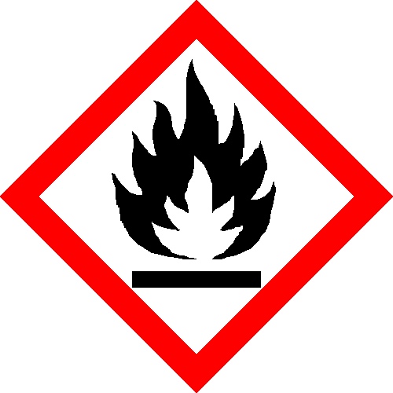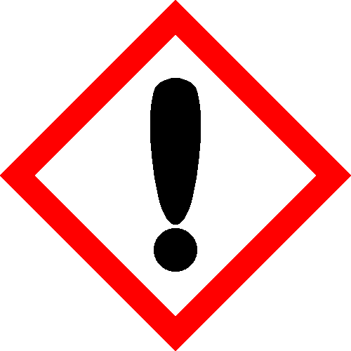

Precautionary statements: P210: Keep away from heat, hot surfaces, sparks, open flames and other ignition sources. No smoking.
P241: Use explosion-proof electrical/ventilating/lighting/.. equipment.
P280: Wear protective gloves/protective clothing/eye protection/face protection.
P302+352: IF ON SKIN: Wash with plenty of water/.
P303+361+353: IF ON SKIN (or hair): Take off immediately all contaminated clothing. Rinse skin with water/shower.
P304+340: IF INHALED: Remove person to fresh air and keep comfortable for breathing.
2.3. Other hazards

Other hazards: In use, may form flammable / explosive vapour-air mixture.
PBT: This product is not identified as a PBT/vPvB substance.

Section 3: Composition/information on ingredients:

3.2. Mixtures
Hazardous ingredients:

ETHYL ACETATE
EINECS | CAS | PBT/WEL | CLP Classification | Percent
205-500-4 | 141-78-6 | - | Flam. Liq. 2: H225; Eye Irrit. 2: H319;  STOT SE 3: H336; -: EUH066 | >75%

DIPENTAERYTHRITYL HEXAACRYLATE
- | TRADE  SECRET | - | Eye Irrit. 2: H319; Skin Sens. 1B:  H317; Aquatic Chronic 3: H412 | 5-10%

ACETONE
200-662-2 | 67-64-1 | - | Flam. Liq. 2: H225; Eye Irrit. 2: H319;  STOT SE 3: H336; -: EUH066 | 1-5%

Section 4: First aid measures

4.1. Description of first aid measures:

Skin contact: Remove all contaminated clothes and footwear immediately unless stuck to skin. Wash
immediately with plenty of soap and water.
Eye contact: Bathe the eye with running water for 15 minutes. Consult a doctor.
Ingestion: Wash out mouth with water. Consult a doctor.
Inhalation: Remove casualty from exposure ensuring one's own safety whilst doing so. Consult a
doctor.

4.2. Most important symptoms and effects, both acute and delayed

Skin contact: There may be irritation and redness at the site of contact.
Eye contact: There may be irritation and redness. The eyes may water profusely.
Ingestion: There may be soreness and redness of the mouth and throat.
Inhalation: There may be irritation of the throat with a feeling of tightness in the chest. Exposure may cause coughing or wheezing.
Delayed / immediate effects: Immediate effects can be expected after short-term exposure.

4.3. Indication of any immediate medical attention and special treatment needed

Immediate / special treatment: Eye bathing equipment should be available on the premises.

Section 5: Fire-fighting measures

5.1. Extinguishing media:

Extinguishing media: Alcohol resistant foam. Water spray. Carbon dioxide. Dry chemical powder. Use water spray to cool containers.

5.2. Special hazards arising from the substance or mixture:

Exposure hazards: Highly flammable. In combustion emits toxic fumes. Forms explosive air-vapour mixture.Vapour may travel considerable distance to source of ignition and flash back.

5.3. Advice for fire-fighters:

Advice for fire-fighters: Wear self-contained breathing apparatus. Wear protective clothing to prevent contact with skin and eyes.

Section 6: Accidental release measures

6.1. Personal precautions, protective equipment and emergency procedures:

Personal precautions: Refer to section 8 of SDS for personal protection details. If outside do not approach from downwind. If outside keep bystanders upwind and away from danger point. Mark out the contaminated area with signs and prevent access to unauthorised personnel. Turn leaking containers leak-side up to prevent the escape of liquid. Eliminate all sources of ignition.

6.2. Environmental precautions:

Environmental precautions: Do not discharge into drains or rivers. Contain the spillage using bunding.

6.3. Methods and material for containment and cleaning up:

Clean-up procedures: Absorb into dry earth or sand. Transfer to a closable, labelled salvage container for
disposal by an appropriate method. Do not use equipment in clean-up procedure which may produce sparks.

6.4. Reference to other sections:

Reference to other sections: Refer to section 8 of SDS.

Section 7: Handling and storage:

7.1. Precautions for safe handling:

Handling requirements: Avoid direct contact with the substance. Ensure there is sufficient ventilation of the area. Do not handle in a confined space. Avoid the formation or spread of mists in the air. Smoking is forbidden. Use non-sparking tools.

7.2. Conditions for safe storage, including any incompatibilities:

Storage conditions: Store in a cool, well ventilated area. Keep container tightly closed. Keep away from
sources of ignition. Prevent the build up of electrostatic charge in the immediate area.
Ensure lighting and electrical equipment are not a source of ignition.
7.3. Specific end use(s):

Specific end use(s): No data available

Section 8: Exposure controls/personal protection:

8.1 Control Parameters

Hazardous Ingredients:

ETHYL ACETATE
 | Workplace exposure limits: |  | Respirable  Dust:
State | 8 hour TWA | 15 min. STEL | 8 Hour TWA | 15 min’STEL
UK | 200 ppm | 400 ppm | --- | ---

ACETONE
UK | 1210 mg/m3 | 3620 mg/m3 | --- | ---

DNEL/PNEC Values:

DNEL / PNEC No data available.

8.2 Exposure Controls:

Engineering measures: Ensure there is sufficient ventilation of the area. Ensure lighting and electrical
equipment are not a source of ignition.

Respiratory protection: Self-contained breathing apparatus must be available in case of emergency.

Hand protection: Protective gloves.

Eye protection: Safety glasses. Ensure eye bath is to hand.

Skin protection: Protective clothing.

Section 9: Physical and chemical properties

9.1. Information on basic physical and chemical properties:

State: Liquid
Colour: Colourless
Odour: Characteristic odour
Evaporation rate: Fast
Viscosity: Non-viscous
Flash point°C: -4

9.2. Other information

No data available.

Section 10: Stability and reactivity:

10.1. Reactivity

Reactivity: Stable under recommended transport or storage conditions.

10.2. Chemical stability

Chemical stability: Stable under normal conditions. Stable at room temperature.

10.3. Possibility of hazardous reactions

Hazardous reactions: Hazardous reactions will not occur under normal transport or storage conditions.
Decomposition may occur on exposure to conditions or materials listed below.

10.4. Conditions to avoid

Conditions to avoid: Heat. Hot surfaces. Sources of ignition. Flames.

10.5. Incompatible materials

Materials to avoid: Strong oxidising agents. Strong acids.

10.6. Hazardous decomposition products

Haz. decomp. products: In combustion emits toxic fumes.

Section 11: Toxicological information

11.1. Information on toxicological effects

Hazardous Ingredients

ETHYL ACETATE
ORL | MUS | LD50 | 4100 | Mg/kg
ORL | RAT | LD50 | 5620 | Mg/kg
SCU | RAT | LDLO | 5 | Gm/kg

ACETONE
IVN | RAT | LD50 | 5500 | Mg/kg
ORL | MUS | LD50 | 3000 | Mg/kg
ORL | RAT | LD50 | 5800 | Mg/kg

Relevant hazards for substance:

Hazard | Route | Basis
Serious eye damage / irritation | OPT | Hazardous: calculated
STOT- single exposure | --- | Hazardous: calculated

Symptoms / routes of exposure:

Skin contact: There may be irritation and redness at the site of contact.
Eye contact: There may be irritation and redness. The eyes may water profusely.
Ingestion: There may be soreness and redness of the mouth and throat.
Inhalation: There may be irritation of the throat with a feeling of tightness in the chest. Exposure may
cause coughing or wheezing.

Delayed / immediate effects: Immediate effects can be expected after short-term exposure.

Section 12: Ecological information

12.1. Toxicity

Hazardous ingredients:

ACETONE
BLUEGILL (Lepomis macrochirus) | LC50 | 8300 | mg/l

12.2. Persistence and degradability

Persistence and degradability: Biodegradable.

12.3. Bioaccumulative potential

Bioaccumulative potential: No bioaccumulation potential.

12.4. Mobility in soil

Mobility: Readily absorbed into soil.

12.5. Results of PBT and vPvB assessment

PBT identification: This product is not identified as a PBT/vPvB substance.

12.6. Other adverse effects

Other adverse effects: Negligible ecotoxicity.

Section 13: Disposal considerations:

13.1. Waste treatment methods:

Disposal operations: Transfer to a suitable container and arrange for collection by specialised disposal
company.
NB: The user's attention is drawn to the possible existence of regional or national
regulations regarding disposal.

Section 14: Transport information

14.1. UN number: UN number: UN1993
14.2. UN proper shipping name: Shipping name: FLAMMABLE LIQUID, N.O.S.
(ETHYL ACETATE, ACETONE, DHPA MIXTURE)
14.3. Transport hazard class(es): Transport class: 3
14.4. Packing group: Packing group: II
14.5. Environmental hazards: Environmentally hazardous: No Marine pollutant: No
14.6. Special precautions for user: Special precautions: No special precautions.

Section 15: Regulatory information

15.1. Safety, health and environmental regulations/legislation specific for the substance or mixture:

15.2. Chemical Safety Assessment:

Section 16: Other information

Other information:

Other information: This safety data sheet is prepared in accordance with Commission Regulation (EU) No
453/2010.
* indicates text in the SDS which has changed since the last revision.

Phrases used in s.2 and s.3: EUH066: Repeated exposure may cause skin dryness or cracking.
H225: Highly flammable liquid and vapour.
H317: May cause an allergic skin reaction.
H319: Causes serious eye irritation.
H336: May cause drowsiness or dizziness.
H412: Harmful to aquatic life with long lasting effects.
Legal disclaimer: The above information is believed to be correct but does not purport to be all inclusive
and shall be used only as a guide. This company shall not be held liable for any damage resulting from handling or from contact with the above product.

